Ex. No.: 4
SQL INJECTION LAB
AIM:
To do perform SQL Injection Lab in TryHackMe platform to exploit various vulnerabilities.

ALGORITHM:
1. Access the SQL Injection Lab in TryHackMe platform using the linkhttps://tryhackme.com/r/room/sqlilab
2. Click Start AttackBox to run the instance of Kalilinux distribution.
3. Perform SQL injection attacks on the followinga) Input Box Non-String
b) Input Box String
c) URL Injection
d) POST Injection
e) UPDATE Statement
4. Perform broken authentication of login forms with blind SQL injection to extract admin password.
5. Perform UNION-based SQL injection and exploit the vulnerable book search function to retrieve the flag.

OUTPUT:
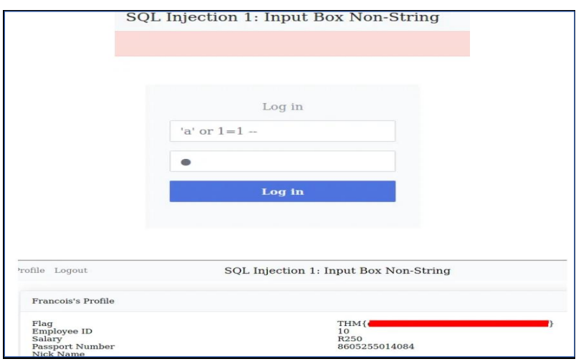
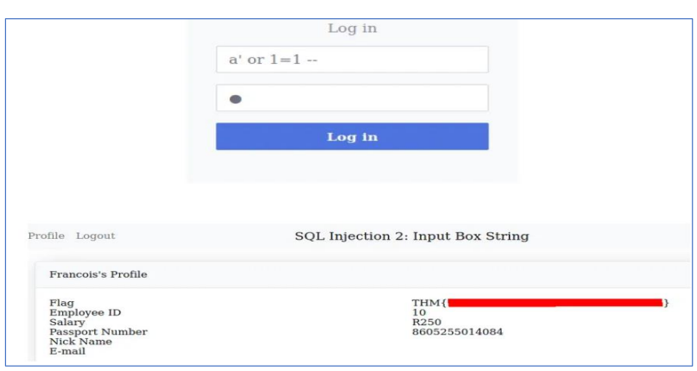

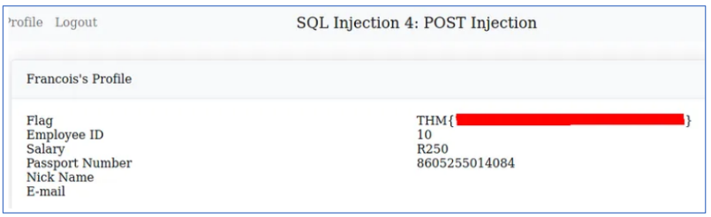
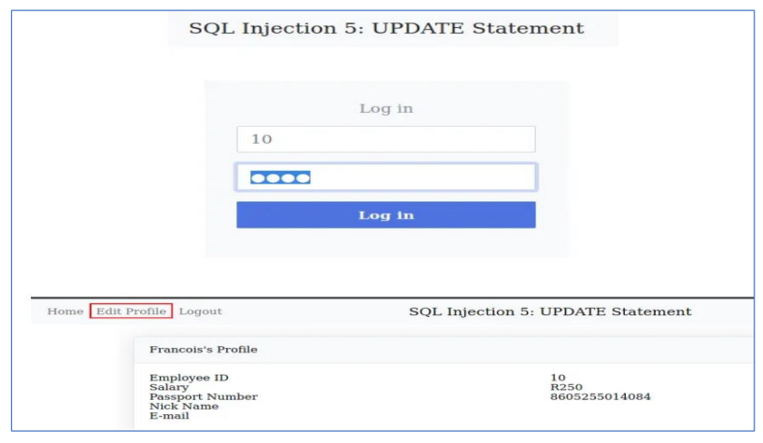
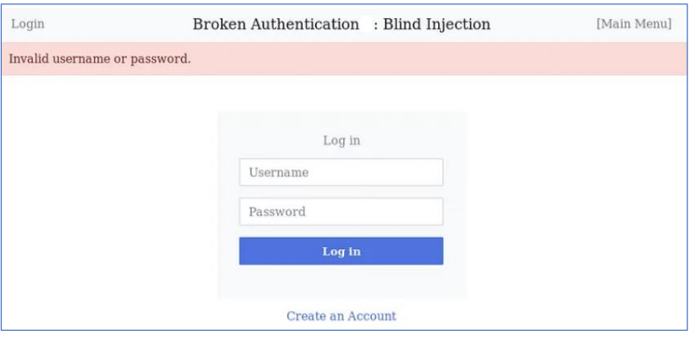
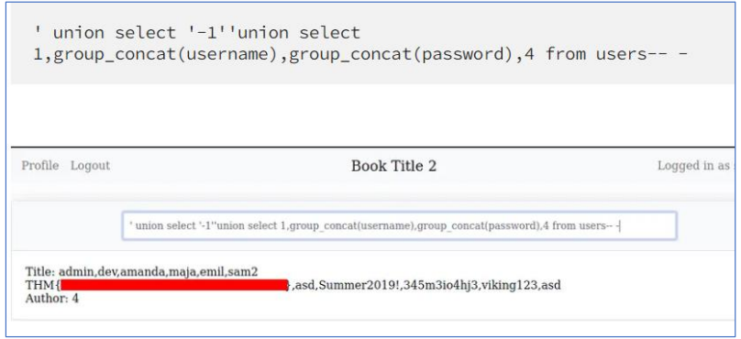

RESULT: Thus, the various exploits were performed using SQL Injection Attack.

